HYBRID INVERTERS

- ORI-OG7-EH1P(3-6)K02-NV-YD-L
- Max. PV Input Voltage- 500V
- Rated AC Output Power- 3-6 kW
- Rated AC Voltage- 230V
- Max. Efficiency- 96.2%
Advantages:
- Supports PV input up to 160% of the inverter's rated DC power, maximizing solar utilization
- Supports up to 21A PV input current, compatible with future higher-power PV modules
- 200% overload for 10s in off-grid mode, ensuring stable startup of motors, water pumps and air conditioners
- Seamless on/off-grid switching in under 10ms, guaranteeing an uninterrupted power supply
- More battery options, compatible with any battery (between 40V-60V)
- Supports existing PV grid-tied power connection for export control and off-grid use
- Multiple methods of generator connection and auto control, enabling flexible local deployment
- Support max 6 units in parallel, expanding system capacity
- Smart Load management, extending backup time for critical loads
- Customizable battery backup level for uninterrupted power
- Supports PV-only off-grid operation, reducing upfront costs
- 7-inch industrial-grade touchscreen, providing a larger, user-friendly interface for local operation
- Ingress protection IP66, for operation in harsh conditions

- ORI-OG7-EH1P(8-12)K02-NV-YD-L
- Max. PV Input Voltage- 500V
- Rated AC Output Power- 8-12 kW
- Rated AC Voltage- 230V
- Max. Efficiency- 96.2%
Advantages:
- Supports PV input up to 160% of the inverter's rated DC power, maximizing solar utilization
- Supports up to 21A PV input current, compatible with future higher-power PV modules
- 200% overload for 10s in off-grid mode, ensuring stable startup of motors, water pumps and air conditioners
- Seamless on/off-grid switching in under 10ms, guaranteeing an uninterrupted power supply
- More battery options, compatible with any battery (between 40V-60V)
- Supports existing PV grid-tied power connection for export control and off-grid use
- Multiple methods of generator connection and auto control, enabling flexible local deployment
- Support max 6 units in parallel, expanding system capacity
- Smart Load management, extending backup time for critical loads
- Customizable battery backup level for uninterrupted power
- Supports PV-only off-grid operation, reducing upfront costs
- 7-inch industrial-grade touchscreen, providing a larger, user-friendly interface for local operation
- Ingress protection IP66, for operation in harsh conditions

- ORI-OG6-EH3P(8-18)K02-NV-YD-L
- Max. PV Input Voltage- 1000 V
- Rated AC Output Power- 8-18kW
- Rated AC Voltage- 380-400 V
- Max. Efficiency- 97.5%
Advantages:
- Supports PV input up to 160% of the inverter's rated DC power, maximizing solar utilization
- Supports up to 21A PV input current, compatible with future higher-power PV modules
- 200% overload for 10s in off-grid mode, ensuring stable startup of motors, water pumps and air conditioners
- Seamless on/off-grid switching in under 10ms, guaranteeing an uninterrupted power supply
- Support three-phase unbalanced output, each phase supports output max. 50% rated inverter power
- supports both DC and AC coupling—making it easy to expand PV, charge batteries, and power loads reliably, even in off-grid conditions
- Multiple methods of generator connection and auto control, enabling flexible local deployment
- Support max 6 units in parallel, expanding system capacity
- Smart Load management with prioritization, extending backup time for critical loads
- Customizable battery backup level for uninterrupted power
- Supports PV-only off-grid operation, reducing upfront costs
- 7-inch industrial-grade touchscreen, providing a larger, user-friendly interface for local operation
- Ingress protection IP66, for operation in harsh conditions

- ORI-OG6-EH3P(30-60)K-H(21A)
- Max. PV Input Voltage- 1000 V
- Rated AC Output Power- 30-60kW
- Rated AC Voltage- 380-400V
- Max. Efficiency- 98.1%
Advantages:
- Supports PV input up to 100kW, maximizing solar utilization.
- Supports a maximum string input current of 21A, ensuring compatibility with high-power PV modules
- Compatible with 100–314Ah battery modules, reducing overall system costs
- Supports fast battery charging with a maximum charging current of 168A
- Two independent battery ports for flexible configurations and easy capacity expansion
- Delivers 160% overload for 2s in off-grid mode, ensuring stable startup of heavy loads
- Offers flexible control for weak grid and genset-hybrid scenarios, reducing investment costs
- Integrates PV and storage for demand management and anti-reverse flow functions
- Provides dynamic reactive power compensation to improve grid power
factor and reduce reactive power charges
- Utility bypass function allows direct grid supply to backup loads
- Patented cooling technology ensures reliable operation even under high-
temperature conditions
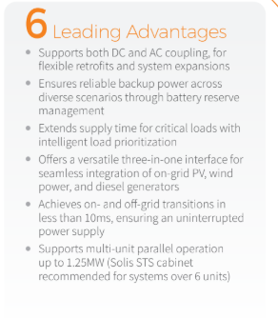
- ORI-OG6-EH3P(80-125)K10-NV-YD-H
- Max. PV Input Voltage- 1000 V
- Rated AC Output Power- 80-125kW
- Rated AC Voltage- 380-400V
- Max. Efficiency- 97.6%
Advantages:
- Supports up to 2x rated PV input, maximizing solar energy utilization
- Supports a maximum string input current of 21A, ensuring compatibility with high-power PV modules
- Compatible with 100–314Ah battery modules, reducing overall system costs
- Supports fast battery charging with a maximum charging current of 200A
- Two independent battery ports for flexible configurations and easy capacity expansion
- Delivers 160% overload for 200ms in off-grid mode, ensuring stable startup of heavy loads
- Offers flexible control for weak grid and genset-hybrid scenarios, reducing investment costs
- Integrates PV and storage for demand management and anti-reverse flow functions
- Provides dynamic reactive power compensation to improve grid power factor and reduce reactive power charges
- Utility bypass function allows direct grid supply to backup loads
- Patented cooling technology ensures reliable operation even under high-
temperature conditions


UTILITY INVERTER
- ORI-OG6-GU3P350K06-EV-ND
- Tech specs.-
Max. PV Input Voltage- 1500 v
Rated AC Output Power- 350kW
Rated AC Voltage- 800v
Max. Efficiency- 99.0%

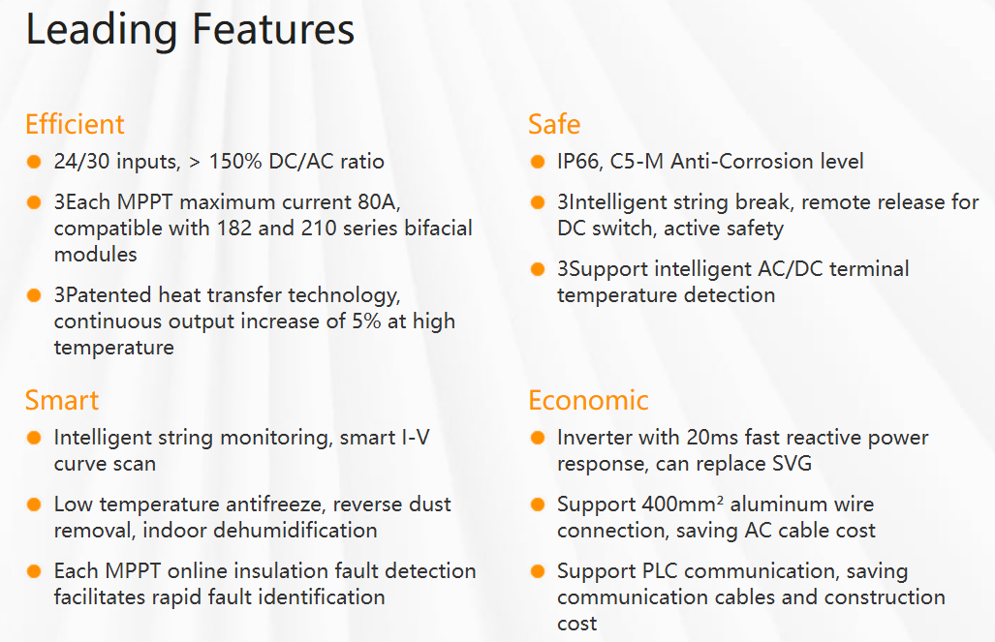

BESS
ORIANA BESS Home

- ORIANA-BESS Home-(5-16)kWh
Low Voltage Batteries
- Battery type: LiFePO4
- Nominal capacity: 5kWh / 10kWh / 16KWh
- Operating voltage: 44.8 - 57.6V
- Cell capacity: 100Ah / 314 Ah
- Recommended charge/discharge current: 50A / 100A / 157A
- Cycle life: ≥6000
- Ingress protection: IP66
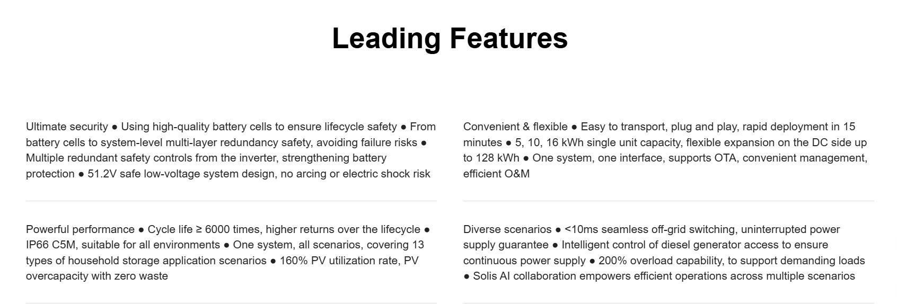

ORIANA BESS C&I
- ORIANA-BESS C&I-(60-261)kWh
High Voltage Batteries
- Battery pack model: ORIANA-BESS C&I-20kWh-8K
- Battery type: LFP
- Battery cell: 314 Ah
- Cell cycle life: 25±2°C, 0.5P, EOL70%≥8000
Leading Features:
- Unified monitoring platform with OTA update capability
- Over 100 third-party VPP/EMS manufacturers on-boarded or being on-boarded,
- Oriana AI smart energy management
- Uses A+ grade cells, ≥8,000+ cycle life
- Intelligent BMS with real-time cell monitoring and fault state recovery
- Five-level safety configuration (distributed temperature sampling + ceramic insulation pad between battery cells+ directional vent channel +aerosol module + mica insulation sheet)
- Vertical stacking structure, quick installationp (A single Pack weighs only 151 kg)
- Modular design, single module 20kWh, maximum single cluster 260kWh, supports up to 6 clusters in parallel, 1560kWh
- The high-voltage control box is designed with dual DC output ports, allowing multiple clusters to be connected in parallel without the need for a combiner box
- 7 inch LCD display and bluetooth for quick commissioning, with automatic battery recognition
- Top brand fans，with 10 years of maintenance-free operation,
- BMS automatically identifies the Pack and quickly locates the faulty Pack
- Integrated four-in-one power electronics (PV+PCS+STS+EMS)
- Supports 200% PV oversizing, maximizing solar energy utilization
- Supports a max. 21A string input current, perfectly matching high-power PV modules
- Supports seamless on-grid and off-grid switching with a transfer time of <10ms
- Supports 160% overload for 200ms in off-grid mode
- Smart port enables multiple energy source inputs, including grid-tied inverters, generators, and AC wind inverters.

ORIANA BESS Core
- ORIANA-BESS Core-(100-261)kWh
100-261kWh System
- Rated energy capacity: 100.48kWh / 120.57kWh / 261.24kWh
- Inverter power rating: 50kW / 60kW / 125kW
- Cell type: LFP 3.2V / 314Ah
- Cell cycle life: 8000
- Anti-corrosion class: IP55(Cabinet)+IP66(Inverter)
Leading Features:
- Four-layer separation (structural, safety, thermal and protective) enables safer operation and true plug-and play installation
- Supports both AC and DC expansion, scalable up to 1.25MW / 15.66MWh
- PCS, PV, STS and EMS integrated into one module with a single centralised controller
- <10 ms backup switching with reduced failure points and no additional equipment required
- IP66 inverter, IP55 cabinet and C5 anti-corrosion protection for demanding sites
- Hybrid air duct design delivers up to 30% improved thermal management efficiency
- Separated, air-cooled architecture reduces system complexity and service time
- Industrial-grade components designed for long-term, maintenance-free operation
- 15-level protection system from cell to cabinet to full system level
- Layered detection and isolation designed to contain and manage extreme scenarios
- Remote monitoring, digitalised O&M and wireless updates
- Supports forecasting, intelligent dispatch and revenue optimisation, with broad EMS/VPP compatibility

